Xbox Interactive Demo Usability Guidelines

Xbox Demo Flow Chart
The following chart summarizes the flow between the states of an Xbox game demo:

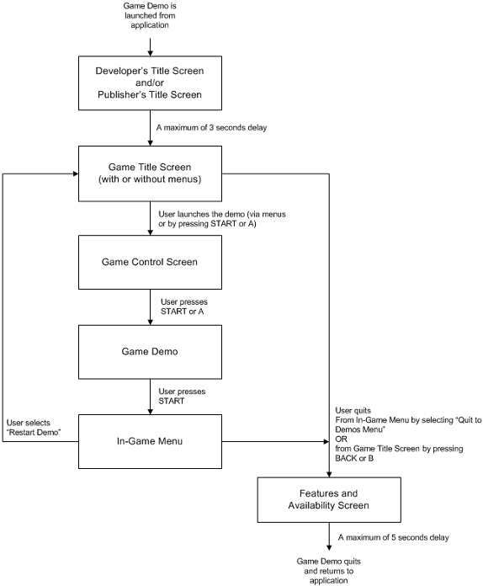

- Developer/Publisher Title Screen: This screen should contain the logo of the Developer and/or the Publisher. It’s the first thing to be shown. It should stay on the screen for no longer than three seconds.
- Game Title Screen: The Game Title Screen is the main menu of the game. If the game demo doesn’t feature menus, the Game Title Screen should read “Press START to begin” and “Press BACK to exit.” If the game demo does feature menus (limited or detailed), they should be displayed and should contain an option that can be selected to quit.
- Game Control Screen: A Game Control Screen is an image of the Xbox Controller with instructions about how to play the game. It should appear when the user starts the demo. This image should clearly read “Press START to continue” and should remain on the screen until the user presses START or A at which point, the demo should start.
- In-Game Menu: While the user is playing the demo, if START is pressed, an In-Game Menu should appear. The following three options should be provided (with any other options that your demo must provide):
  - View Game Controls – This option brings up the Control Screen.
  - Restart Demo – This option returns the user to the Game Title Screen.
  - Quit to Demos Menu – This option quits the Interactive Demo.
- Ending a Demo (Features and Availability Screen): Publishers may create an ending screen that states when the final game will be available, contains a list of features in the final game, gives hints, and/or displays any other marketing messages to the player that are pertinent to the demo or final game. From this screen, users will be returned to the launcher interface after a period of time no longer than five seconds.

